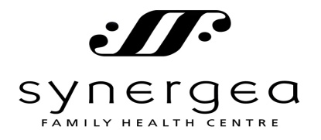

FINANCIAL/CANCELLATION POLICY

Our Financial policy is that payment is expected when goods and/or services are rendered. If you have extended health benefits, payment is still expected at the time of service, and we will provide all documentation for you to submit to your benefits administrator.

EXTENDED HEALTH BENEFITS & THIRD PARTY INSURANCE COVERAGE
Extended health benefits cover many types of health care services provided at our clinic. It is your responsibility to confirm coverage for our services. That being said we also suggest that you investigate what services your benefits cover, and make full use of all the benefits that you have paid for. We will provide all necessary documentation for you to submit to your extended health care provider. We are able to bill directly to Blue Cross Insurance, which we are pleased to submit for you.

PAYMENT
It is the policy of Synergea that all fees charged for services rendered and products purchased are to be paid by cash, cheque, debit, Visa, or MasterCard at the time of each visit. We charge an additional $35.00 for NSF cheques.

CLINIC VISITS
Scheduled time with your practitioner, regardless of whether treatment is rendered or not, will be billed as a clinic visit.

CANCELLATION POLICY
In the event that a scheduled appointment with one of the Synergea practitioners is unattended, the following policy will apply:
- We require 24 hour notice for cancellations. Please be advised that e-mail reminders are a courtesy only and appointments are the responsibility of the client.
- A “No-show” with no notification as in #1 will be charged the full fee for the missed visit.
- If there is a cancellation the same day of the appointment, the full fee will be charged for the missed visit.
- We require credit card information to be retained on file in the event of missed appointments.

NATUROPATHIC / CHINESE HERBAL MEDICATIONS
You may be prescribed medications, which may be purchased at our clinic or elsewhere. Please be aware that most insurance companies will NOT cover the medicinary items that are prescribed or dispensed. There are no refunds or returns for purchased medicinary items as we can only guarantee potency and quality of products that have been stocked and inspected in our office at all times.

Thank you for respecting your practitioner’s schedule and time in following this policy. Should you have any questions, kindly speak with one of our front desk assistants, or directly with your practitioner.

I have read and agree to my financial obligations with regards to receiving services/products at Synergea Family Health Centre.

Name__________________________________________ Date: _______________________________

Signature: _____________________________________Witness: _____________________________

